DBMS Practical No.: 23

**Name: yash ajay magar**

**Experiment No 23: Implement PL/SQL program based on Exception Handling (User-defined exceptions)**

Exercise:

1. Write a PL/SQL program by using the user defined exception.

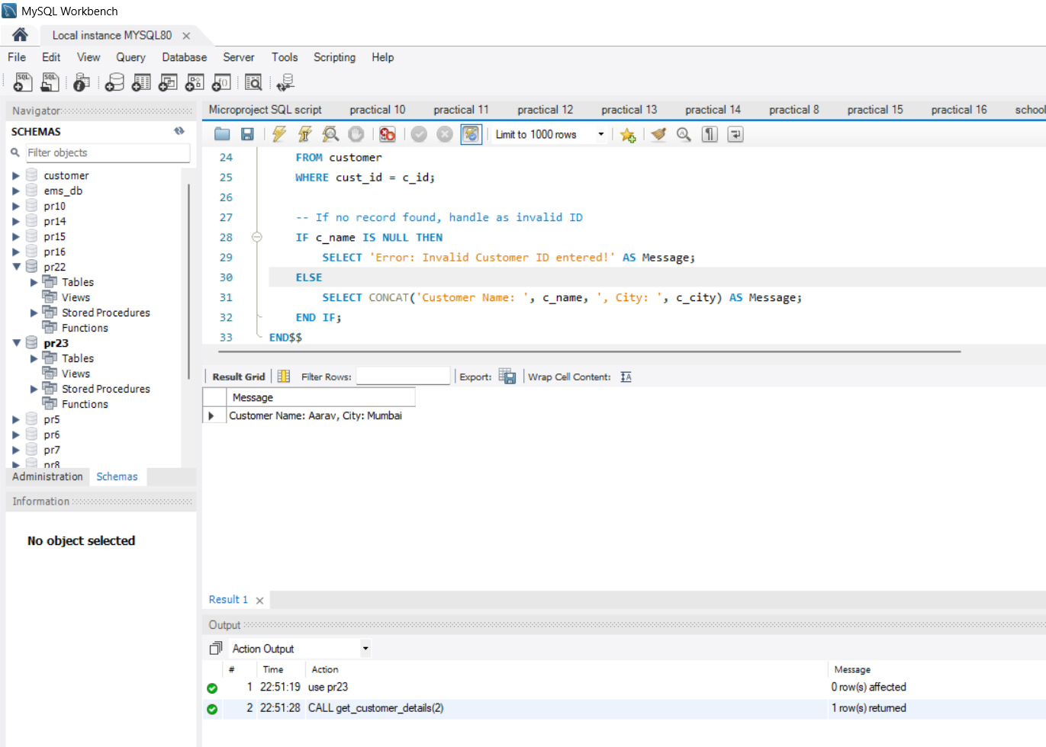

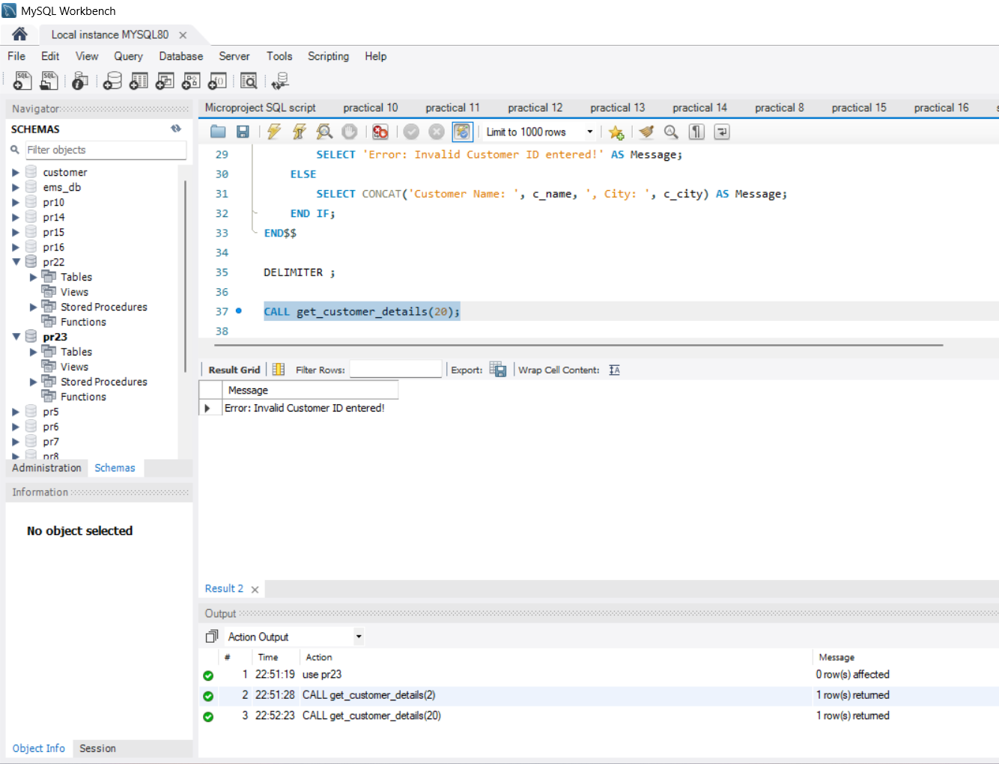

1. Write a PL/SQL program that asks for customer Id, when user enters invalid Id, the exception Invalid-Id is raised.

